HOMEWORK ASSIGNMENT 1

1) Problem 2.3 - 3

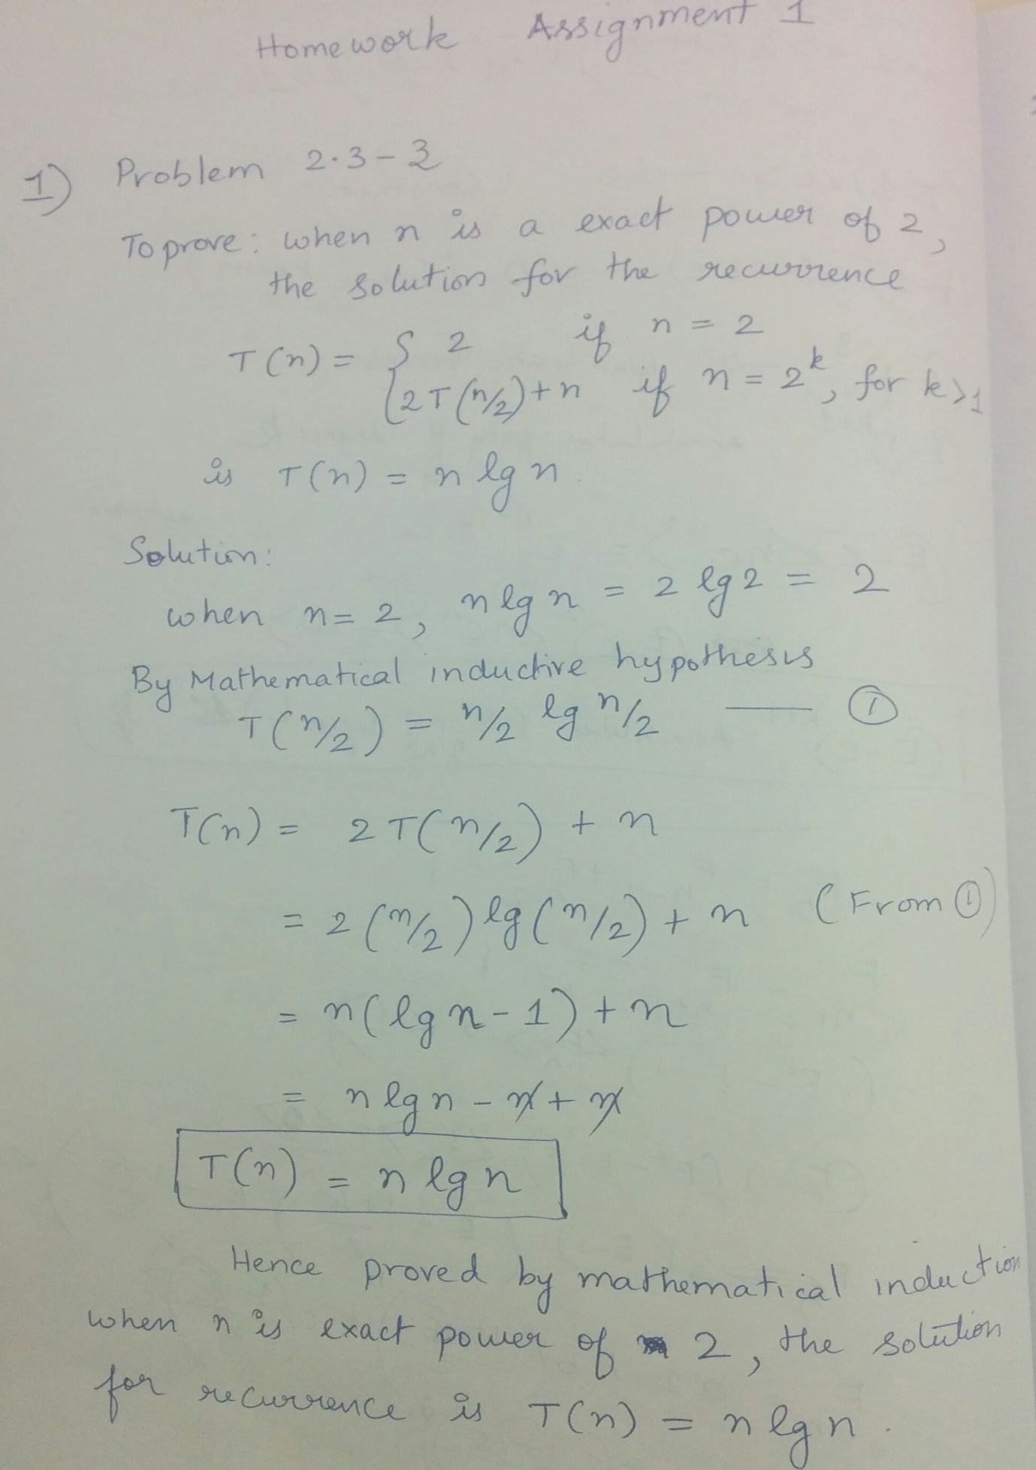

2) Problem 2.3 - 4

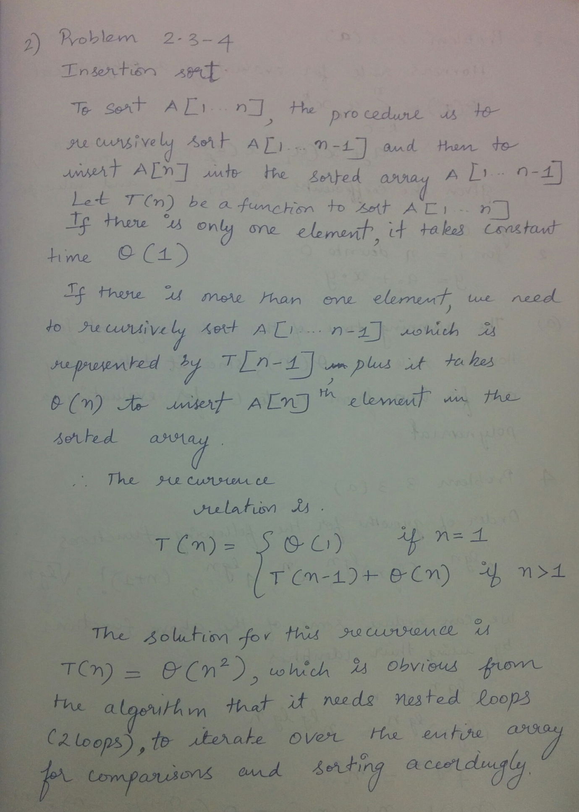

3) Problem 2 - 3 (a)

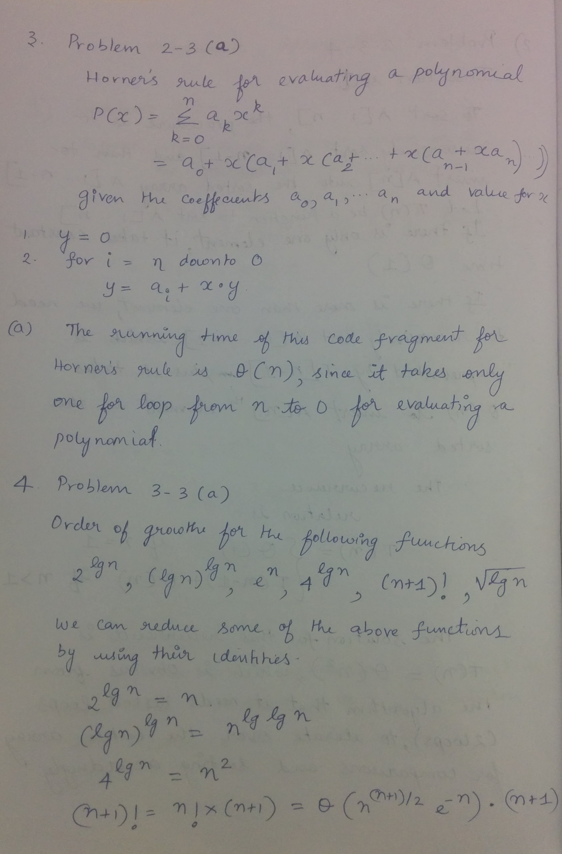

4th problem Continuation and 5th Problem 4 - 3 (a)

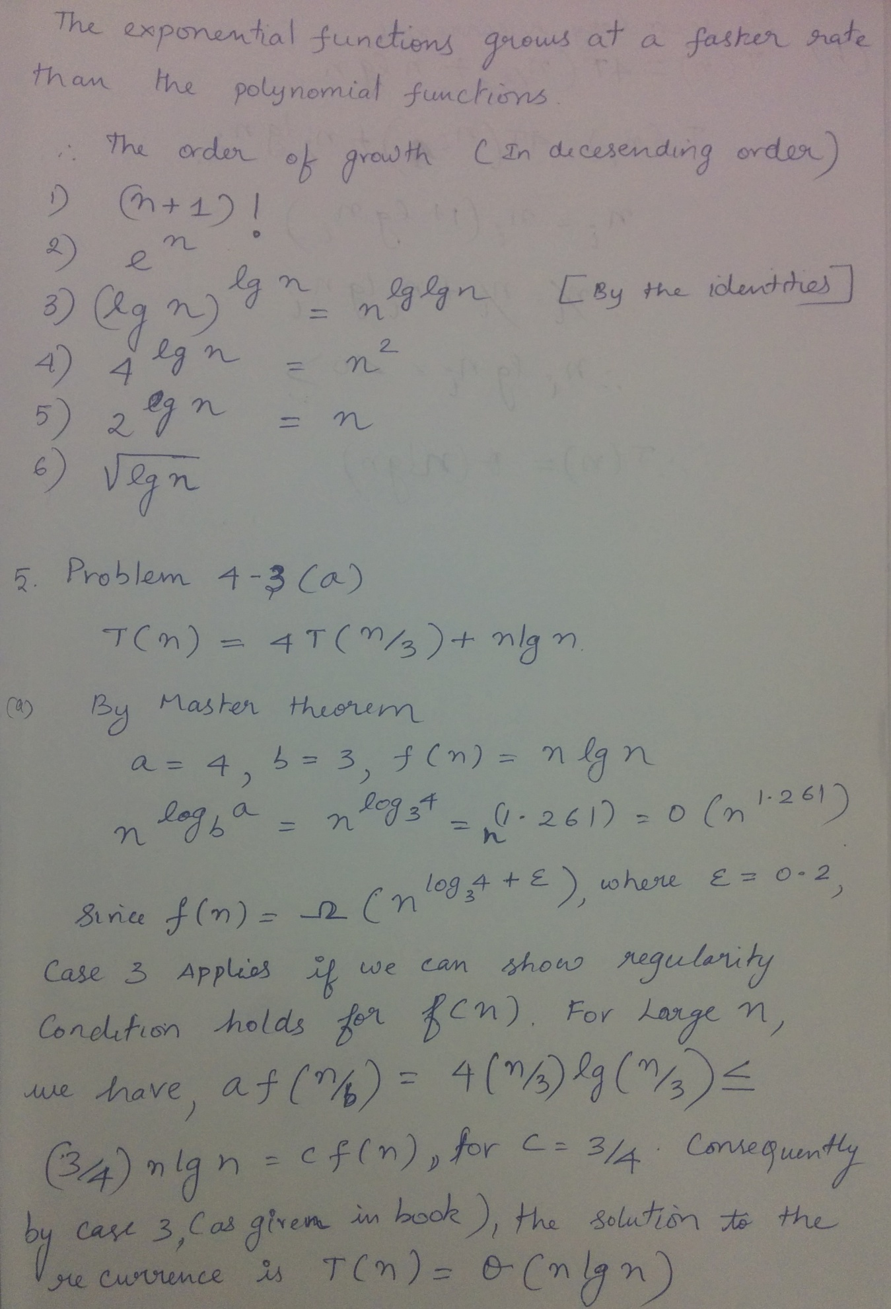

5th problem continuation

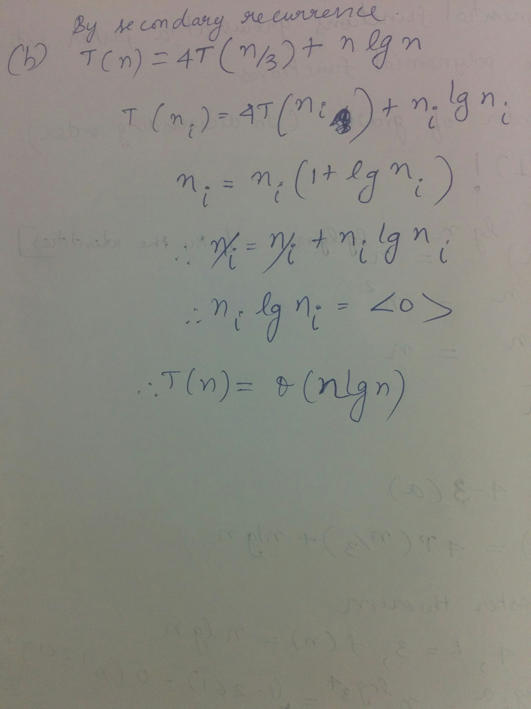

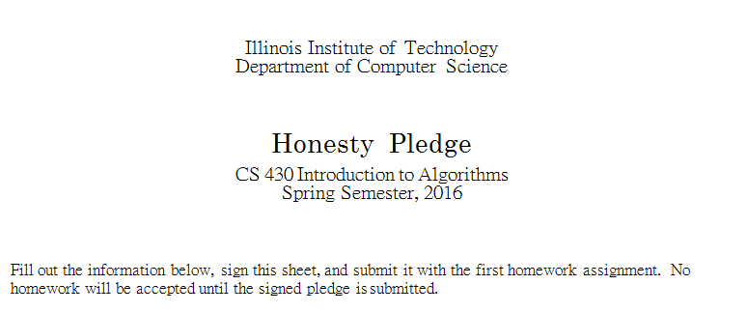

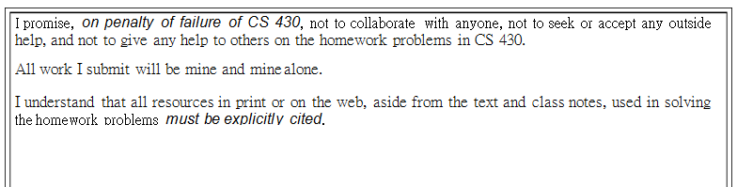

Sairam Kannan K. Sairam A20355970 01/20/2016

